Collection lab

SubmitBy

Mithlendu Kumar

QN1

Write a program that ask student name ,rollno and marks from user .  
 Initilaize value of class using constructor.define to string method in class create Studentmain class to call all class function Ask 5 record from user and store then in LinkedList and display all data

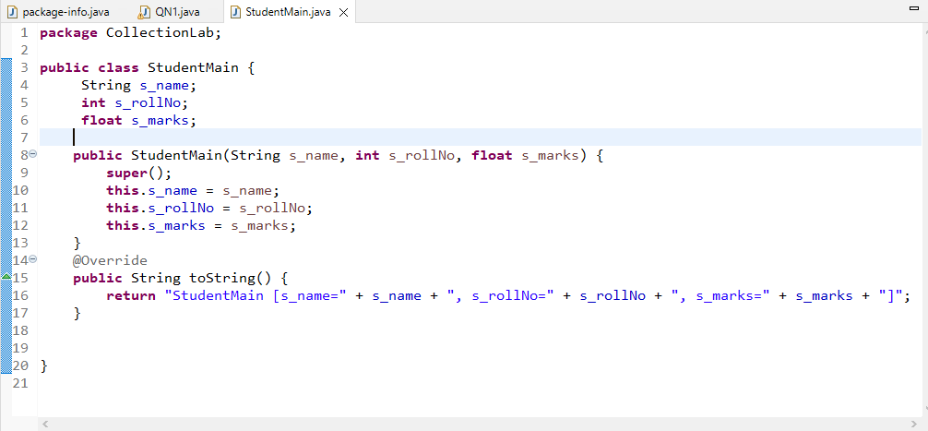

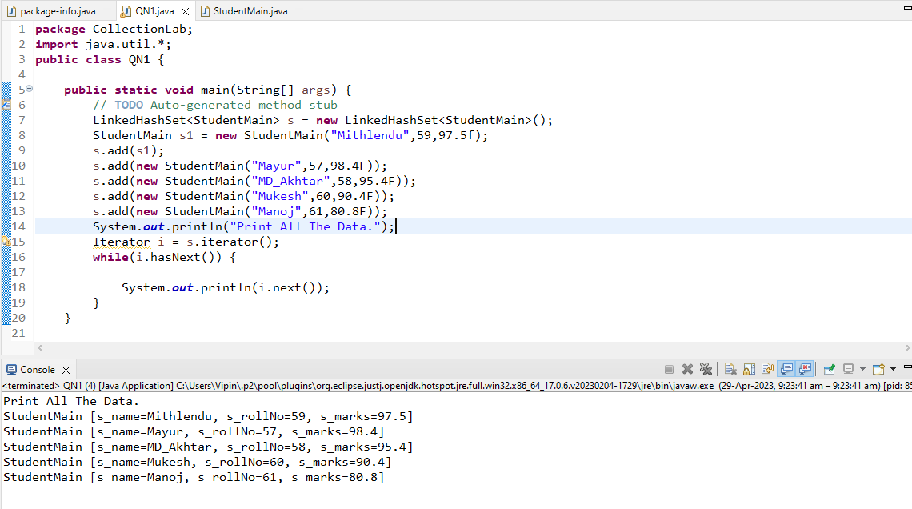

QN2

write a program to create vector of string and add elements to vector  
check vector class main functions like  
1)adding elements in vector  
2)traversing all vector elements  
3)print vector object hashcode  
4)get particular element value usin get function  
5)print size and capacity of vector  
6)add null data in vector  
7)print index valueof null elements  
hint v.indexOf(null)  
8)add element at particular postition  
hint  
v.insertElementAt("",5);  
9)remove particular element from vector

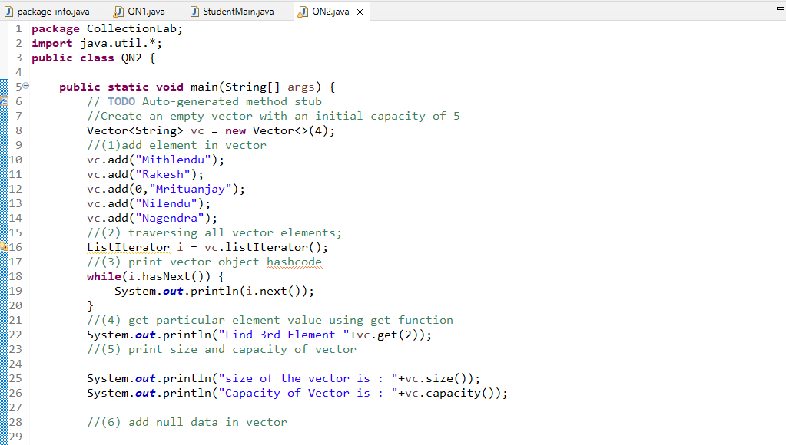

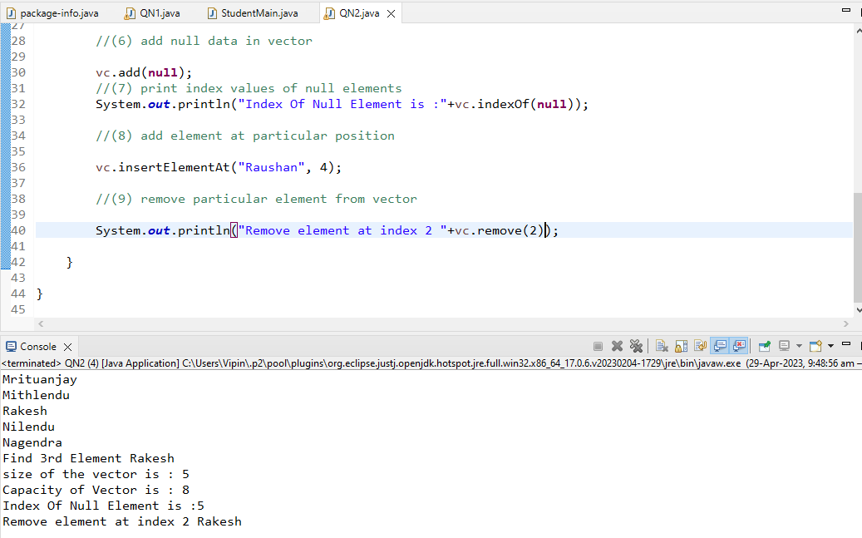

QN3

3 Write program for maintaining book record of library .  
use ArrayList Class to hold an multiple book record and display all book record using iterator .  
b) traverse arraylist and store each book record in class object and display book name

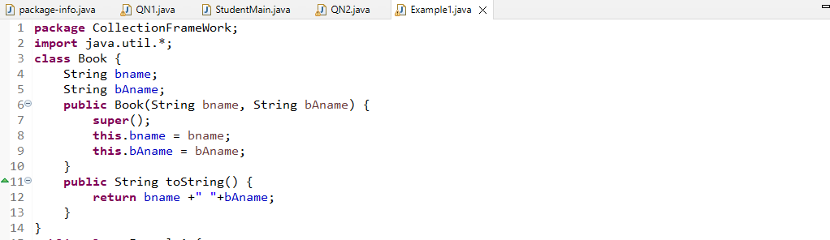

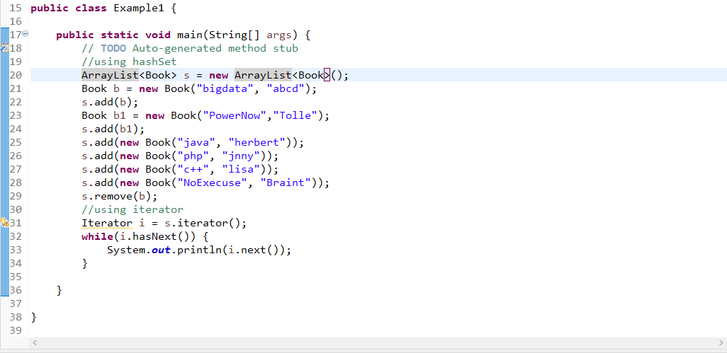

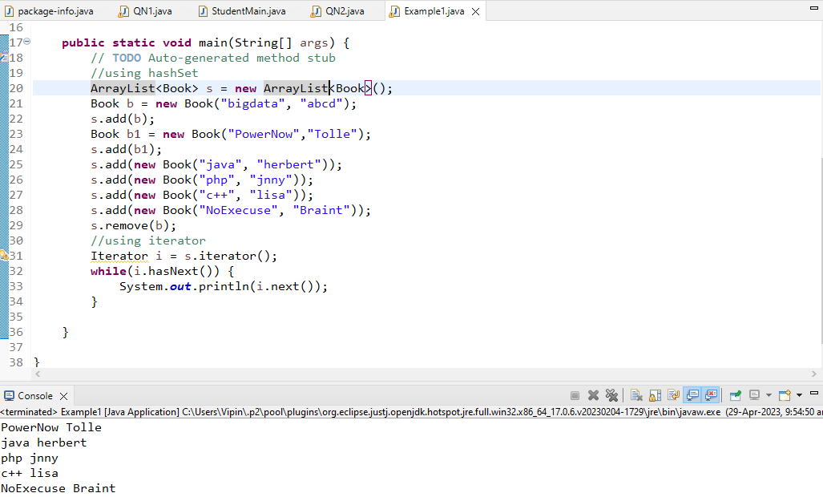

QN5

Write a Java program to create a new tree set, add some colors (string) and print out the tree set.

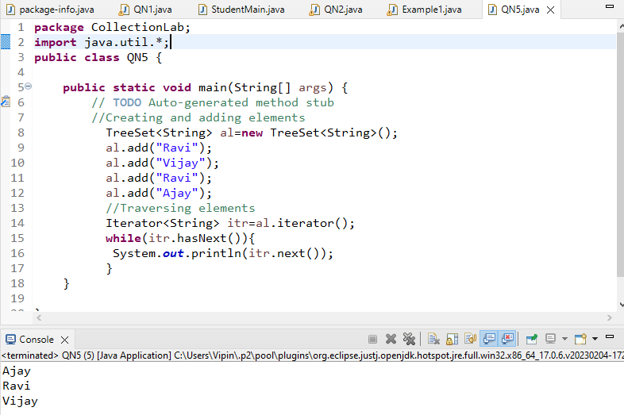

QN6

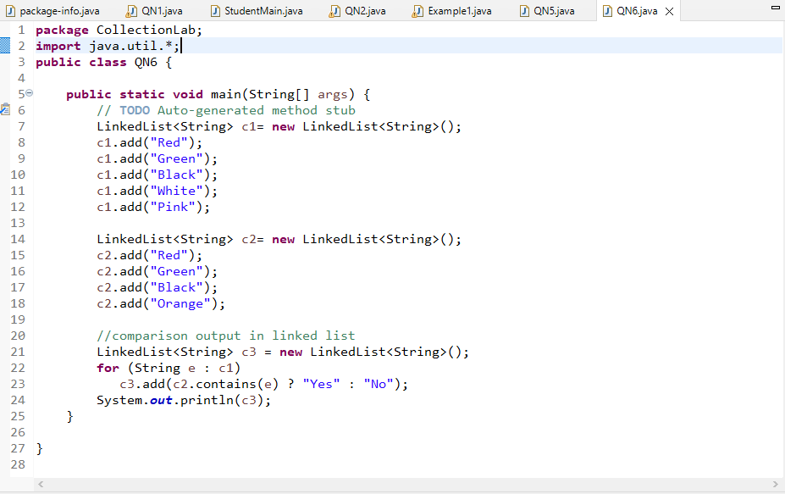

Output

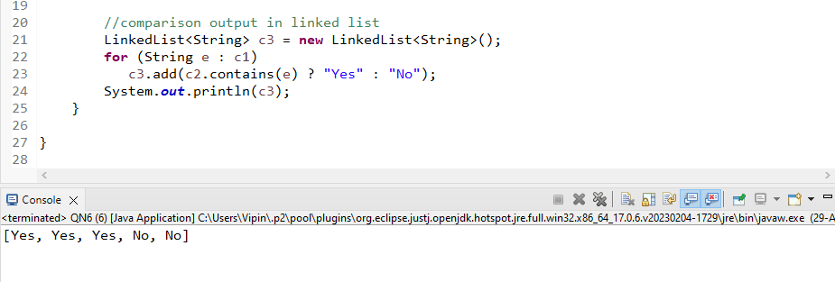

QN7

write a java program to compare two hashSet

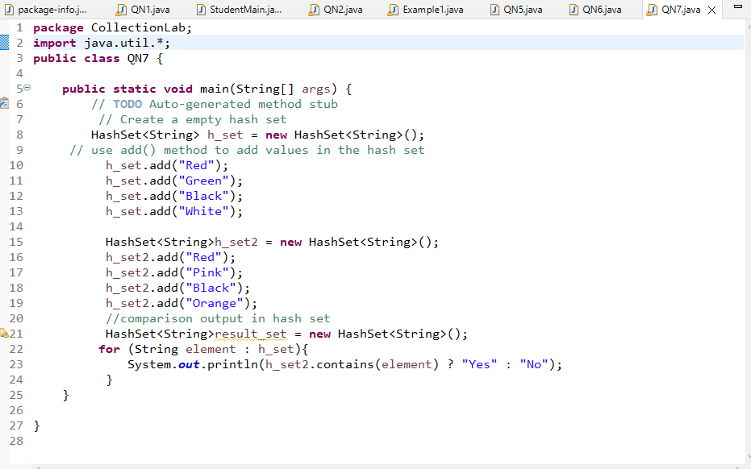

Output

